Team Wildcard

By Juliana De La Parra

Nicole Emich

Mike Harris

Felix Zhu

**Overview** **2**

**Updates** **3**

High level requirements 4

Use case diagram 4

High level analysis 5

Persistence 6

Table layout 6

Discussion of how your design meet the requirements 6

User interface 7

Sample UI 7

Discussion of how your design meet the requirements 7

**Drop Classes (1 of 2)** **8**

**Instructor** **9**

**Appendix** **10**

Team Issue Resolution Agreement 10

Milestone Contribution Summary 11

Milestone 1 11

Milestone 2 11

Milestone 3 11

Final submission 12

Milestone Screen Shots 12

Milestone 2 12

Milestone 3 (UI Screenshots) 13

Final Submission 13

# 

# **Overview**

Team Wildcard will be developing an application that’s similar to DePaul’s Campus Connect application, which is a web portal that allows students to perform self-service tasks related to their coursework. We will be creating a similar portal that delivers a subset of features such as adding courses, dropping courses, viewing grades/progress, and managing personal information.

The team members working on this project are Juliana De La Parra, Nicole Emich, Mike Harris, and Felix Zhu.

The location of the source code: <https://github.com/mikeharris-github/SE452-WildCard>

# **Updates**

|  |  |
| --- | --- |
| Date | What was accomplished |
| 09/14 | Milestone 1 |
| 10/12 | Set up and confirmation of databases working |
| 10/13 | Milestone 2 |
| 10/26 | Milestone 3 Updates |

## High level requirements

This shows how students look for classes and which professor will do the class

### Use case diagram

Classes needed

View grades

Manage personal information

Drop classes



Student



### High level analysis

## Persistence

### Table layout

User Authentication

Academic records

Personal information (NoSQL)

Enroll classes

Course catalog (NoSQL)

Course Wishlist (NoSQL)

Course Cart (NoSQL)

Term

Department

Courses

Student

Instructor

### Discussion of how your design meet the requirements

We created 12 tables for our databases (8 SQL and 4 NoSQL). Our team decided to use PostgreSQL and H2 for our databases. A deeper dive into our tables and the columns within them can be found on our moqup page here:

<https://app.moqups.com/RZSGmVXk05/edit/page/ad64222d5>

* 1. Lessons Learned

**Milestone 2**

Our project group had struggles with GitHub where different members were unable to run the project code or would run into new errors as updates were pushed. This led to multiple repositories being created and a lot of clean up necessary to get the code to where it is now. A lesson moving forward is that we need to be careful and proactive when thinking about version control. This way, in the event of any problems, we don’t need to start from scratch or a much earlier version of the project.

**Milestone 3**

This was multiple members’ first exposure to HTML and embedded HTML, so this milestone exposed various team members to front-end development for the first time.

## User interface

### Sample UI

Student Portal Login

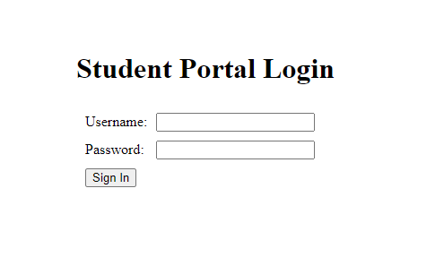

Student Homepage

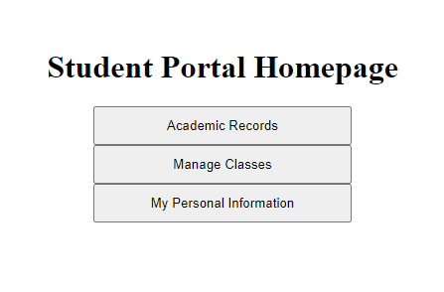

# 

# Drop Classes (1 of 2)

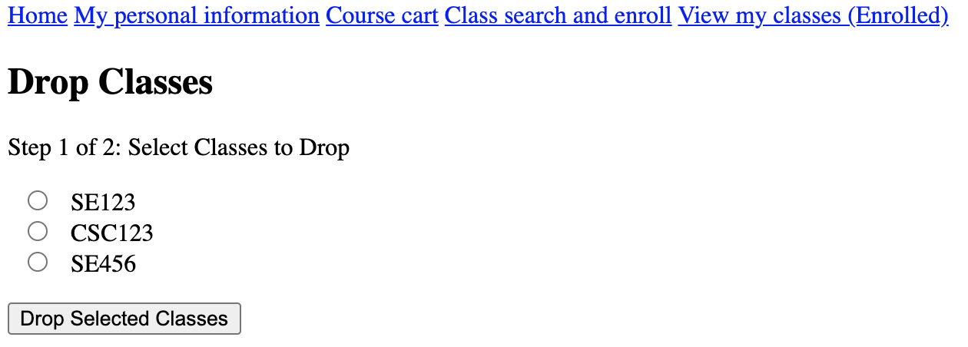

Drop Classes (2 of 2)

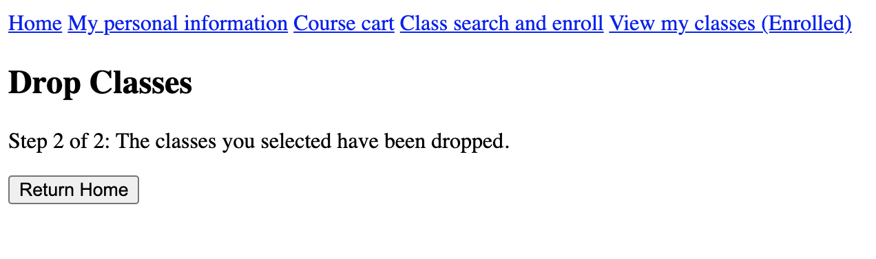

Course Cart

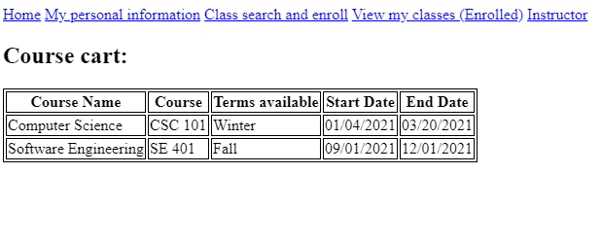

# Instructor

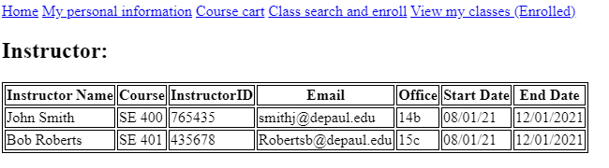

My Personal Information

# 

View My Classes

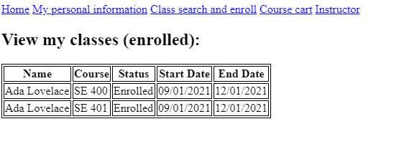

### Discussion of how your design meet the requirements

-We were able to develop 8 user interfaces, which was more than the 4 user interfaces (1x per team member) required as part of the milestone.

# 

# Appendix

## Team Issue Resolution Agreement

When a conflict arises in the group, we will determine all possible options and put it to a group vote. The majority vote wins and will be the final decision. If there’s a tie, it will result in a coin flip.

If all else fails and we can still not come to an agreement or we have an issue in which we find ourselves not able to resolve, we will consult with Professor Yu.

## Milestone Contribution Summary

### Milestone 1

|  |  |
| --- | --- |
| Name | What was contributed |
| Mike |  |
| Juliana |  |
| Nicole |  |
| Felix |  |

### Milestone 2

|  |  |
| --- | --- |
| **Name** | **What was contributed** |
| Mike | Wrote table code and debugged database set up |
| Juliana | Wrote table code and finalized Milestone 2 document |
| Nicole | Created databases and verified table creation/data population |
| Felix | Wrote table code and debugged database set up |

### Milestone 3

|  |  |
| --- | --- |
| **Name** | **What was contributed** |
| Mike | Created HTML pages for Dropping Classes |
| Juliana | Created HTML pages for Course Cart, My Personal Information, Instructor, and View Classes |
| Nicole | Finished setting up the persistence databases with all of our tables for postgres and mongo |
| Felix | Created HTML pages for Login and Home Page |

### 

### Final submission

## Milestone Screen Shots

### Milestone 2

* + 1. Clean compile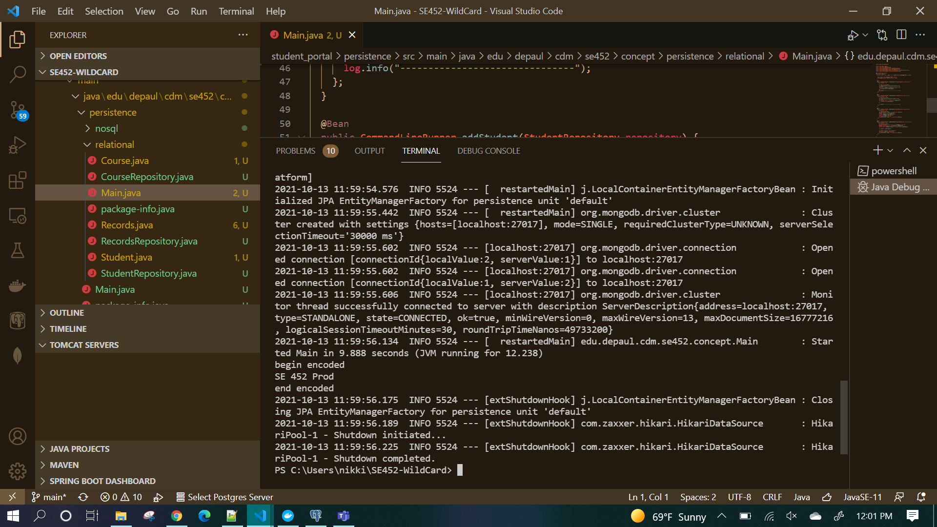
    2. Database and query

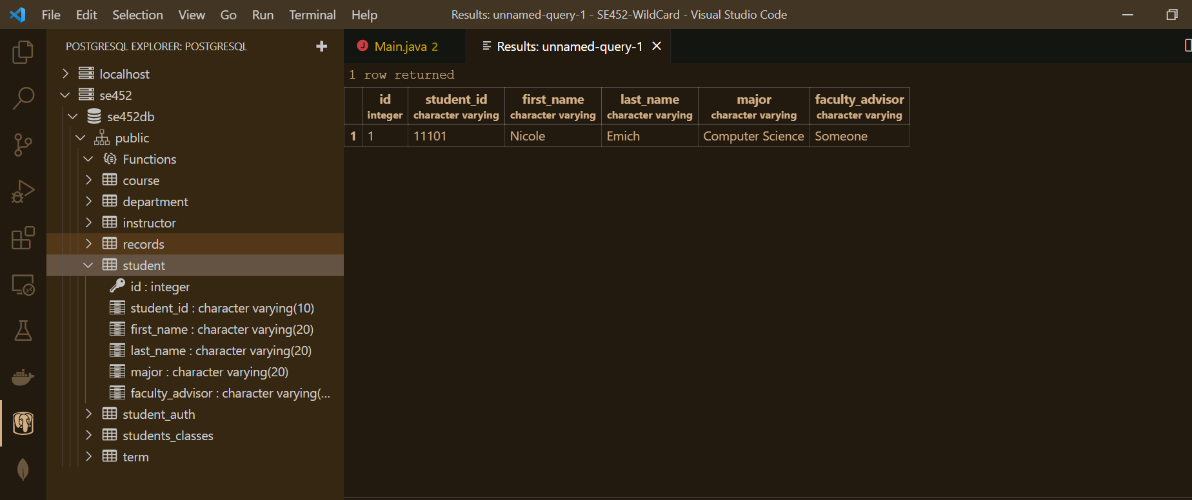

### Milestone 3 (UI Screenshots)

**See Section 3 “User Interface” on page 7.**

### Final Submission